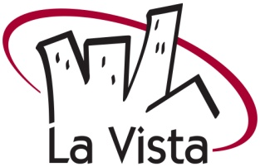

Press Release
April 8, 2020

For more information contact: Mitch Beaumont,
Community Relations Coordinator
402-331-4343 or 402-980-2863

Salute to Summer Festival Cancelled

The rapidly changing COVID-19 situation has drastically altered many aspects of normal, everyday life, including limitations on public gatherings.

Based on already established health measures and anticipating that large, public gatherings may not be feasible in late May, the City of La Vista has made the tough decision to cancel this year’s Salute to Summer Festival.

“This year’s festival would have been a celebration of our 60th anniversary and would have taken place with a new format and new schedule of events,” said Mayor Douglas Kindig. “Cancelling this event is the last thing we want to do, but the City Council was unanimous in the decision and we feel it is necessary to ensure the health and safety of our community.”

Additionally, all events and programming through the end of May have been cancelled.

It is possible the City could still host some kind of community celebration later in the year, but until restrictions are lifted and conditions improve, it is not prudent to schedule a new event at this time.

No decision has been made about summer events and programming, including the Library’s Summer Reading Program. The City will keep the community informed as future event decisions are made.

###

